Regular and Irregular Faces

Definition
# Source: AI Source: Provided by: [Data Path: Persons Table -> ID Column: 1, Name_En Column: Motasem Essam] -> From: [ChatGPT] on [7/25/2026]
In solid geometry, faces are the surfaces that form the boundary of a three-dimensional solid. A face may be classified as regular or irregular according to the shape of its boundary and the equality of its sides and angles.
- Regular face: A flat polygon whose sides are all equal in length and whose interior angles are all equal.
- Irregular face: A flat polygon whose sides and angles are not all equal, or that otherwise fails to meet the conditions for a regular polygon.
These terms apply to polygonal faces of polyhedra, such as cubes, prisms, and pyramids. A curved surface, such as the surface of a cylinder, is not a regular or irregular polygonal face.
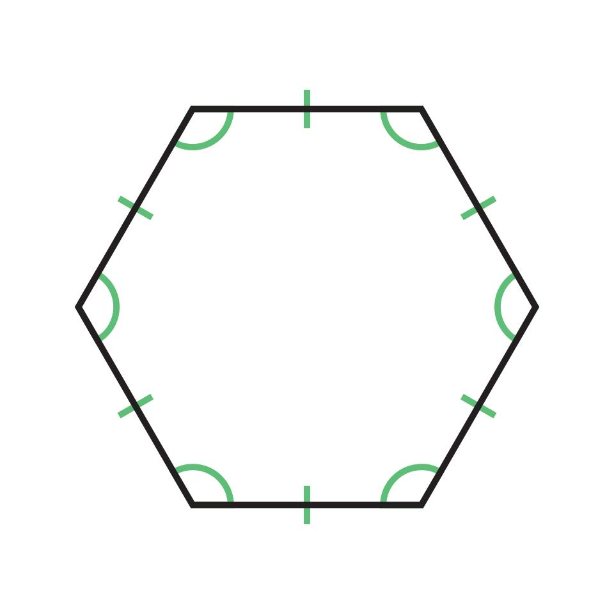
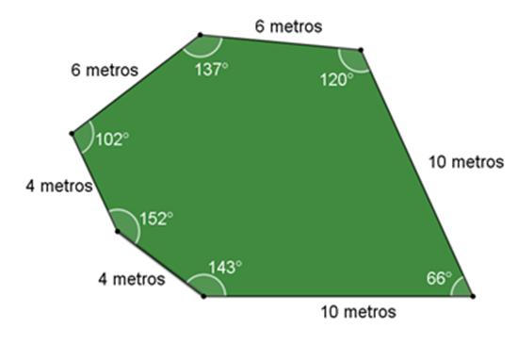
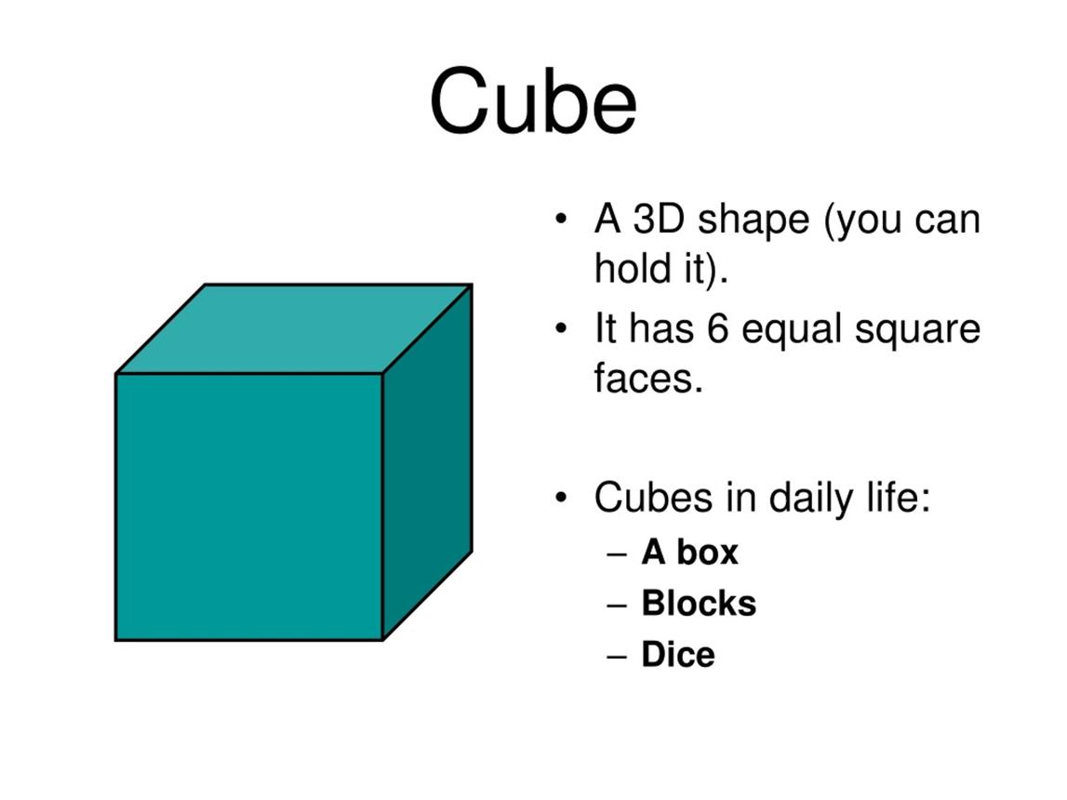

Simple Definition
# Source: AI Source: Provided by: [Data Path: Persons Table -> ID Column: 1, Name_En Column: Motasem Essam] -> From: [ChatGPT] on [7/25/2026]
A regular face has a regular polygon as its shape, with all sides and all interior angles equal.
An irregular face has an irregular polygon as its shape, meaning its sides or interior angles are not all equal.
Examples:
- A square face of a cube is regular.
- An equilateral triangular face is regular.
- A non-square rectangular face is irregular as a polygon because its angles are equal, but its side lengths are not all equal.
- A triangle with unequal sides is an irregular face.
Important: Having equal angles alone does not make a polygon regular. Both its side lengths and interior angles must be equal.

Classification Tree
# Source: AI Source: Provided by: [Data Path: Persons Table -> ID Column: 1, Name_En Column: Motasem Essam] -> From: [ChatGPT] on [7/25/2026]
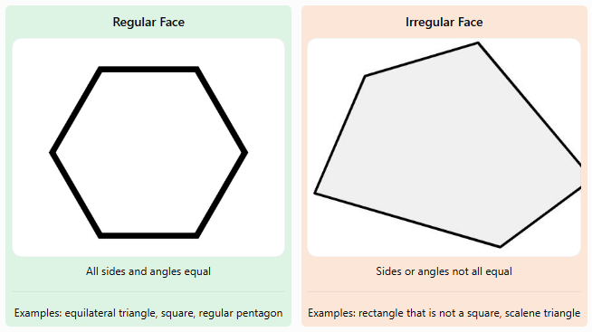Regular Face
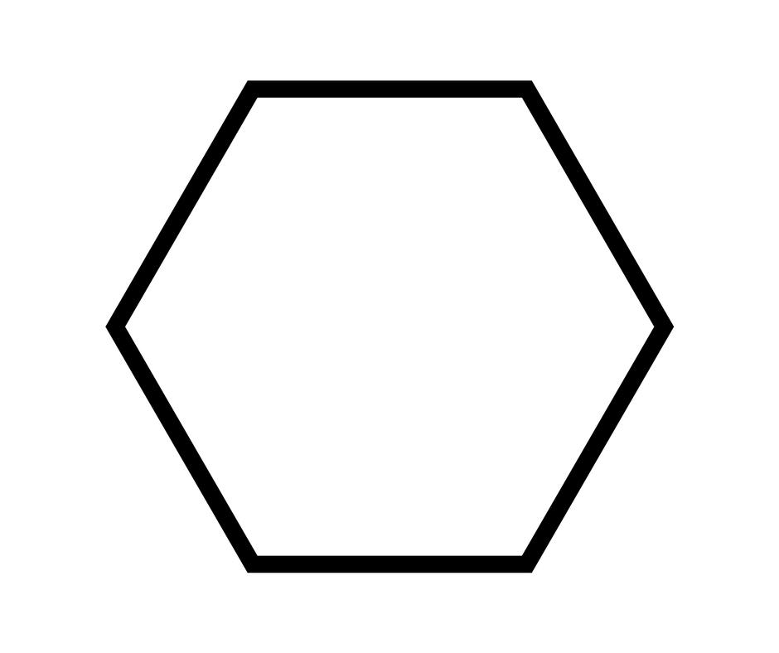
All sides and angles equal
Examples: equilateral triangle, square, regular pentagon
Irregular Face
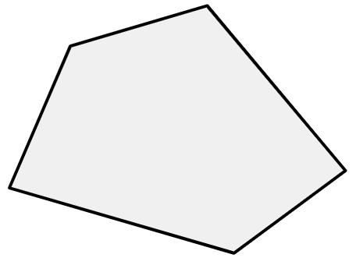
Sides or angles not all equal
Examples: rectangle that is not a square, scalene triangle
This classification concerns the geometry of each individual face. A solid may have all regular faces, all irregular faces, or a mixture of both.

Key Characteristics
# Source: AI Source: Provided by: [Data Path: Persons Table -> ID Column: 1, Name_En Column: Motasem Essam] -> From: [ChatGPT] on [7/25/2026]
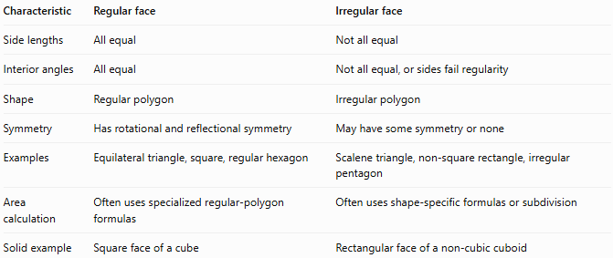
Characteristic | Regular face | Irregular face
Side lengths | All equal | Not all equal
Interior angles | All equal | Not all equal, or sides fail regularity
Shape | Regular polygon | Irregular polygon
Symmetry | Has rotational and reflectional symmetry | May have some symmetry or none
Examples | Equilateral triangle, square, regular hexagon | Scalene triangle, non-square rectangle, irregular pentagon
Area calculation | Often uses specialized regular-polygon formulas | Often uses shape-specific formulas or subdivision
Solid example | Square face of a cube | Rectangular face of a non-cubic cuboid

Geometric Representation
# Source: AI Source: Provided by: [Data Path: Persons Table -> ID Column: 1, Name_En Column: Motasem Essam] -> From: [ChatGPT] on [7/25/2026]
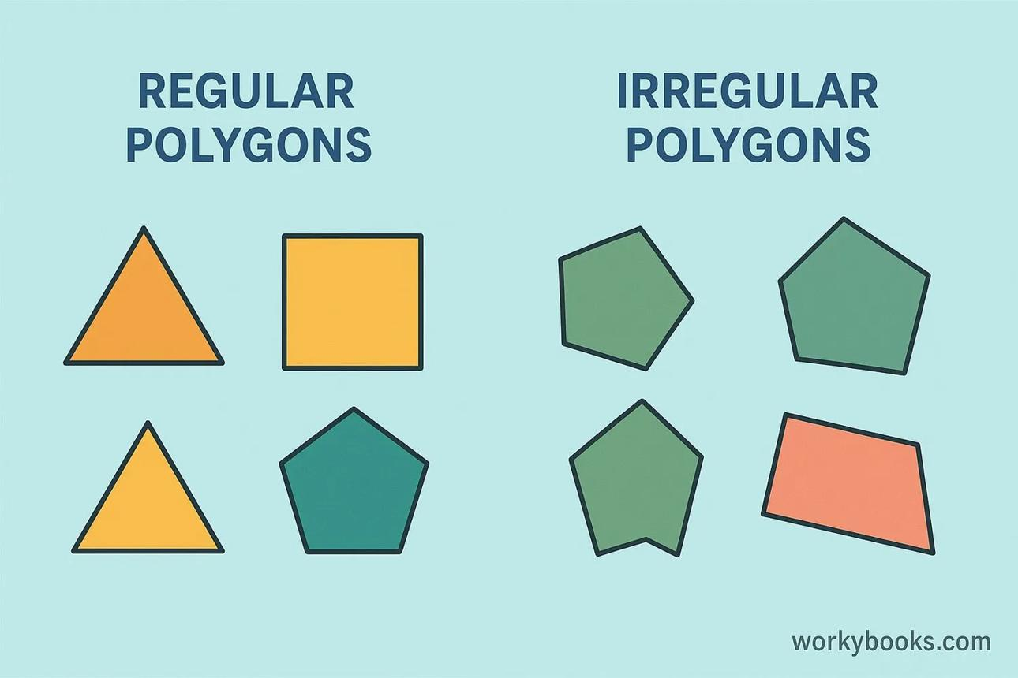

A. Regular faces
# Source: AI Source: Provided by: [Data Path: Persons Table -> ID Column: 1, Name_En Column: Motasem Essam] -> From: [ChatGPT] on [7/25/2026]
A regular face is a regular polygon. Examples include:
- Equilateral triangle: three equal sides and three equal angles of ${60}^{∘}$.
- Square: four equal sides and four equal angles of ${90}^{∘}$.
- Regular pentagon: five equal sides and five equal interior angles of ${108}^{∘}$.
- Regular hexagon: six equal sides and six equal interior angles of ${120}^{∘}$.
These polygons can appear as faces of suitable polyhedra.

B. Irregular faces
# Source: AI Source: Provided by: [Data Path: Persons Table -> ID Column: 1, Name_En Column: Motasem Essam] -> From: [ChatGPT] on [7/25/2026]
An irregular face is a polygon that does not have all sides and all interior angles equal.
Examples include:
- Scalene triangle: all three sides have different lengths.
- Non-square rectangle: all four angles are equal, but the side lengths are not all equal.
- Irregular pentagon: its sides or interior angles are not all equal.
- Irregular quadrilateral: a quadrilateral whose sides and angles do not satisfy the conditions of a regular polygon.

C. Regular and irregular faces on the same solid
# Source: AI Source: Provided by: [Data Path: Persons Table -> ID Column: 1, Name_En Column: Motasem Essam] -> From: [ChatGPT] on [7/25/2026]
A solid can contain both types of faces. For example, a right square pyramid can have a regular square base and four isosceles triangular lateral faces. Those triangles are regular only if they are equilateral; otherwise, they are irregular.

6. Mathematical Representation and Formulas

A. Conditions for a regular face
# Source: AI Source: Provided by: [Data Path: Persons Table -> ID Column: 1, Name_En Column: Motasem Essam] -> From: [ChatGPT] on [7/25/2026]
For a regular polygon with $n$ sides, where $n≥3$:
$$\text{All side lengths}=s$$
$$\text{Each interior angle}=\frac{\left(n-2\right){180}^{∘}}{n}$$
For example, a regular hexagonal face has six equal sides and each interior angle is
$$\frac{\left(6-2\right){180}^{∘}}{6}={120}^{∘}$$

B. Interior angle sum
# Source: AI Source: Provided by: [Data Path: Persons Table -> ID Column: 1, Name_En Column: Motasem Essam] -> From: [ChatGPT] on [7/25/2026]
For any simple polygon with $n$ sides, regular or irregular:
$$S=\left(n-2\right){180}^{∘}$$
For a pentagonal face:
$$S=\left(5-2\right){180}^{∘}={540}^{∘}$$
The angle sum does not determine whether the face is regular. The equality of its sides and angles must also be considered.

C. Area of a regular polygonal face
# Source: AI Source: Provided by: [Data Path: Persons Table -> ID Column: 1, Name_En Column: Motasem Essam] -> From: [ChatGPT] on [7/25/2026]
If a regular polygon has perimeter $p$ and apothem $a$, its area is
$$A=\frac{12}{a}p$$
If it has $n$ sides of length $s$, its area can also be calculated as
$$A=\frac{ns^{2}}{4\tan\left(π/n\right)}$$
Here, the angle in the tangent function is in radians.

D. Area of an irregular polygonal face
# Source: AI Source: Provided by: [Data Path: Persons Table -> ID Column: 1, Name_En Column: Motasem Essam] -> From: [ChatGPT] on [7/25/2026]
The area formula depends on the shape.
For a triangular face:
$$A=\frac{12}{b}h$$
For a rectangular face:
$$A=lw$$
For an irregular polygon, one approach is to divide it into triangles, calculate their areas, and add them together.

Worked Examples
# Source: AI Source: Provided by: [Data Path: Persons Table -> ID Column: 1, Name_En Column: Motasem Essam] -> From: [ChatGPT] on [7/25/2026]
Example 1: Classifying a square face
A face of a solid is a square with each side measuring $5\text{ cm}$.
Step 1: Check the side lengths.
All four sides measure $5\text{ cm}$.
Step 2: Check the interior angles.
Each interior angle measures ${90}^{∘}$.
Conclusion: The face is a regular polygonal face because all its sides and interior angles are equal.
Its area is
$$A=s^{2}=5^{2}=25{\text{ cm}}^{2}$$
Example 2: Classifying a rectangular face
A face of a cuboid measures $8\text{ cm}$ by $4\text{ cm}$.
Step 1: Compare the side lengths.
Two sides measure $8\text{ cm}$, and two measure $4\text{ cm}$.
Step 2: Check the angles.
All four angles are ${90}^{∘}$.
Conclusion: The face is an irregular quadrilateral because its side lengths are not all equal, even though its angles are equal.
Its area is
$$A=lw=8\left(4\right)=32{\text{ cm}}^{2}$$
Example 3: Classifying a triangular face
A triangular face has side lengths $6\text{ cm}$, $6\text{ cm}$, and $6\text{ cm}$.
All three sides are equal. Therefore, the triangle is equilateral, and each angle is ${60}^{∘}$.
Conclusion: The face is regular.
If the same triangle had side lengths $5\text{ cm}$, $5\text{ cm}$, and $8\text{ cm}$, it would be isosceles but irregular because its side lengths are not all equal.
Example 4: A solid with both regular and irregular faces
Consider a rectangular prism with dimensions $6\text{ cm}$, $4\text{ cm}$, and $3\text{ cm}$.
Its faces are rectangles with dimensions:
- Two faces measuring $6×4\text{ cm}$.
- Two faces measuring $6×3\text{ cm}$.
- Two faces measuring $4×3\text{ cm}$.
Because none of these rectangles is a square, all six faces are irregular quadrilaterals.
By contrast, a cube has six square faces, all of which are regular polygons.

Comparison with Related Concepts
# Source: AI Source: Provided by: [Data Path: Persons Table -> ID Column: 1, Name_En Column: Motasem Essam] -> From: [ChatGPT] on [7/25/2026]
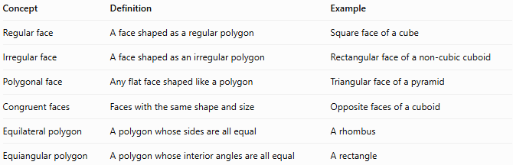
Concept | Definition | Example
Regular face | A face shaped as a regular polygon | Square face of a cube
Irregular face | A face shaped as an irregular polygon | Rectangular face of a non-cubic cuboid
Polygonal face | Any flat face shaped like a polygon | Triangular face of a pyramid
Congruent faces | Faces with the same shape and size | Opposite faces of a cuboid
Equilateral polygon | A polygon whose sides are all equal | A rhombus
Equiangular polygon | A polygon whose interior angles are all equal | A rectangle
Important distinction: Equilateral and equiangular do not individually mean regular. A regular polygon must be both equilateral and equiangular. For example, a non-square rectangle is equiangular but not equilateral, while a non-square rhombus is equilateral but not equiangular.

Applications of Regular and Irregular Faces
# Source: AI Source: Provided by: [Data Path: Persons Table -> ID Column: 1, Name_En Column: Motasem Essam] -> From: [ChatGPT] on [7/25/2026]
- Architecture: Comparing symmetric and asymmetric building surfaces.
- Engineering: Designing parts with uniform or varying dimensions.
- Computer graphics: Representing three-dimensional objects using polygon meshes.
- Manufacturing: Calculating material requirements for flat panels.
- Mathematics education: Understanding polygon classification, symmetry, and surface area.
- Packaging: Designing regular containers or irregularly shaped packages.

Key Points
# Source: AI Source: Provided by: [Data Path: Persons Table -> ID Column: 1, Name_En Column: Motasem Essam] -> From: [ChatGPT] on [7/25/2026]
- A regular face is a polygon whose sides and interior angles are all equal.
- An irregular face fails at least one of these equality conditions.
- A square is regular; a non-square rectangle is irregular.
- A regular face may occur on a regular or non-regular solid.
- A solid can have both regular and irregular faces.
- Regularity is a property of an individual polygon, not automatically of the entire solid.
- Regular and irregular polygonal faces are both flat and two-dimensional.

Conclusion
# Source: AI Source: Provided by: [Data Path: Persons Table -> ID Column: 1, Name_En Column: Motasem Essam] -> From: [ChatGPT] on [7/25/2026]
Regular and irregular faces are classifications of polygonal faces based on their side lengths and interior angles. Regular faces have equal sides and equal interior angles, while irregular faces do not satisfy both conditions. This distinction helps classify the faces of polyhedra, study symmetry, and calculate surface areas.

